Email Flow for Registration

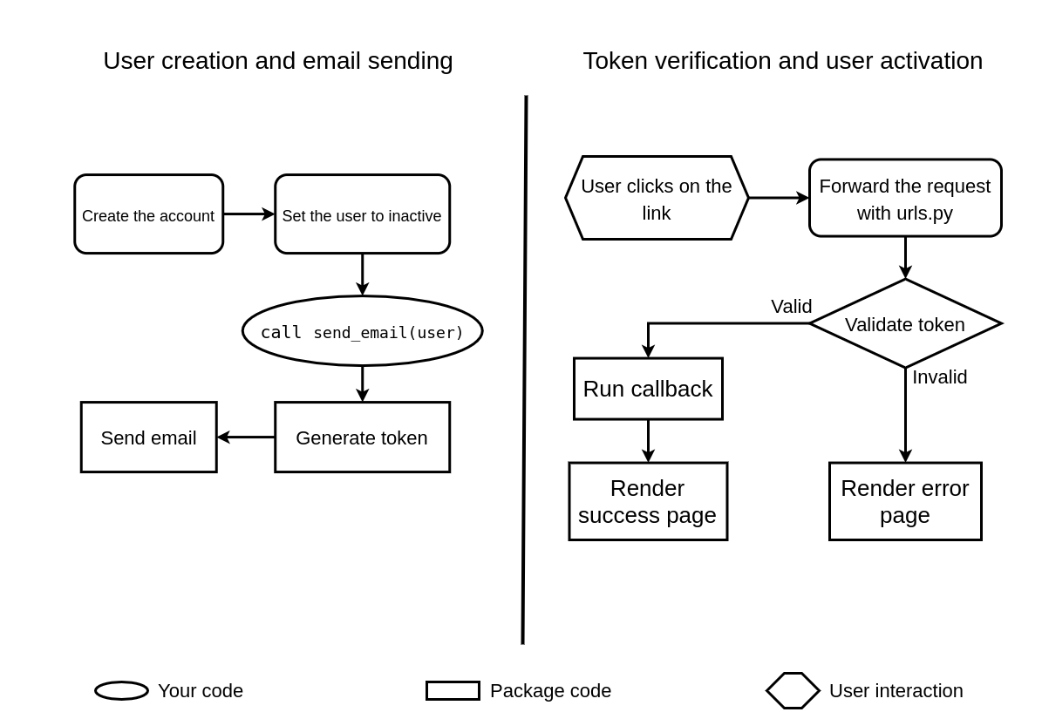

Github library:- <https://github.com/kranthi0987/django-email-verification>